Poisson distribution

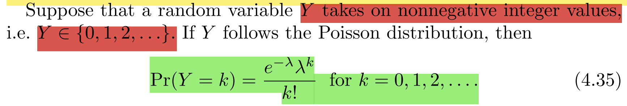

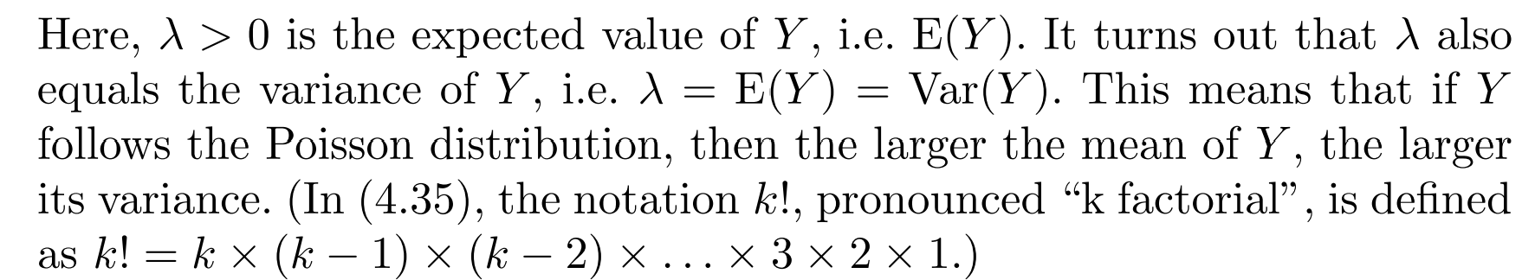

Proof: https://statproofbook.github.io/P/poiss-var.html